Homework 1 Compilers Feb 25th, 2010

Virpobe Paireepinart

Note: The program I used to draw the diagrams puts tau instead of epsilon but that is the meaning. I couldn’t figure out how to change the default symbol.

1. Construct an NFA for the following RE (a|b)*abb. Assume alphabet has just two symbols a and b.

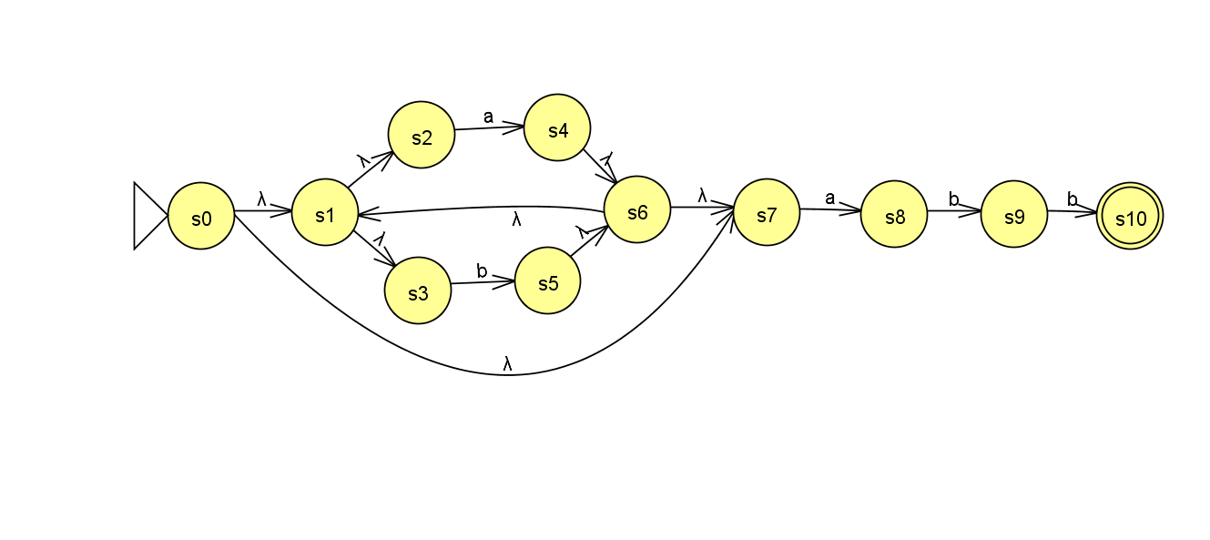

1. (a) Give a regular expression for the language that contains all strings that start with a and end with bb. Assume alphabet has just two symbols a and b.

a(a|b)*bb

2. (b) Construct an NFA to recognize the above language

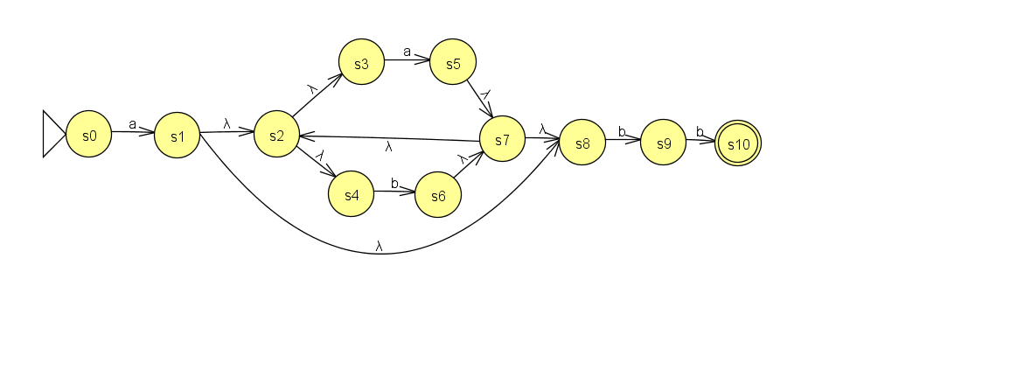

2. (c) Convert the NFA to DFA

|  |  |  |  |
| --- | --- | --- | --- |
| States | | ε-closure(move(∑,*)) | |
| DFA | NFA | a | b |
| q0 | s0 | s1, s2, s3, s5, s7, s8 | s0 |
| q1 | S1, s2, s3, s4, s8 | S5, s7, **s8, s2, s3, s4** | S6, s7, **s8, s2, s3, s4** |
| q2 | S2, s3, s4 | S5, s7, **s8, s2, s3, s4** | S6, s7, **s8, s2, s3, s4** |
| q3 | S3 | S5, s7, **s8** |  |
| q4 | S4 |  | S6, s7, **s8** |

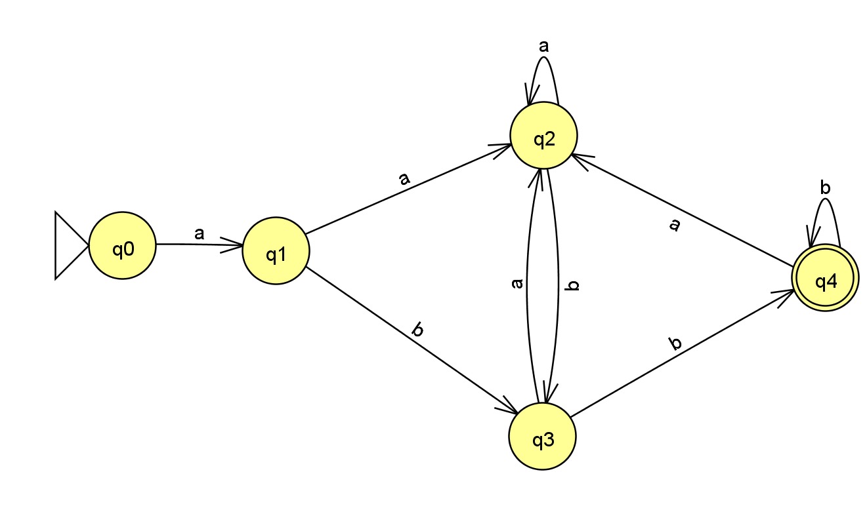

1. (d) Minimize the DFA

State q1 and q2 can be combined.

